1.PROGRAM ON SQRT():

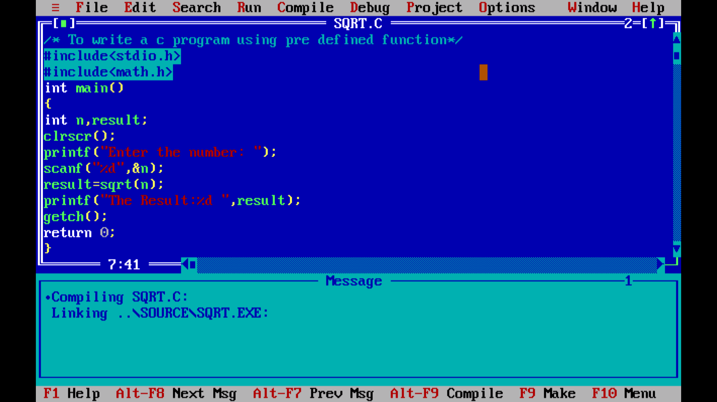

OUT PUT: for pre defined function SQRT()

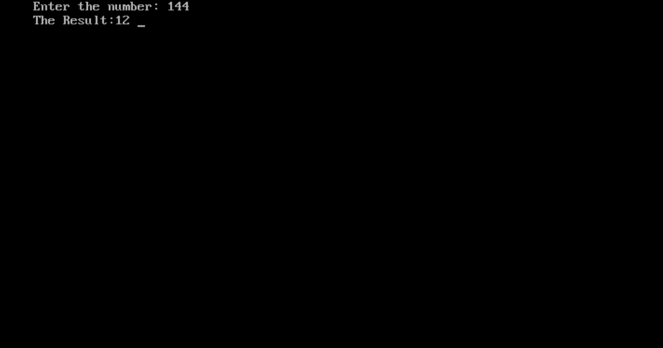

2.PROGRAM ON POW():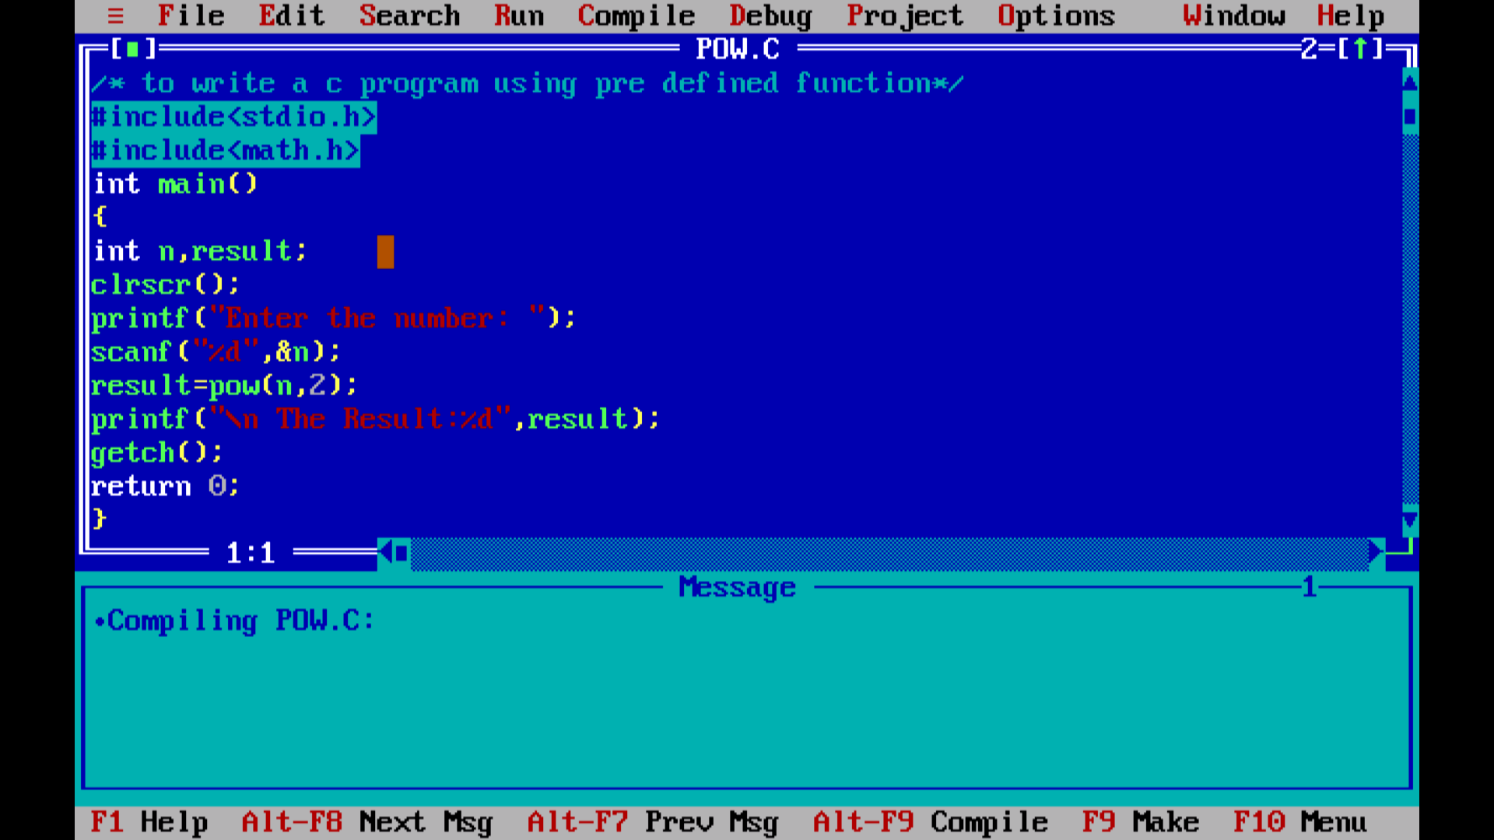

OUT PUT: for pre defined function pow()

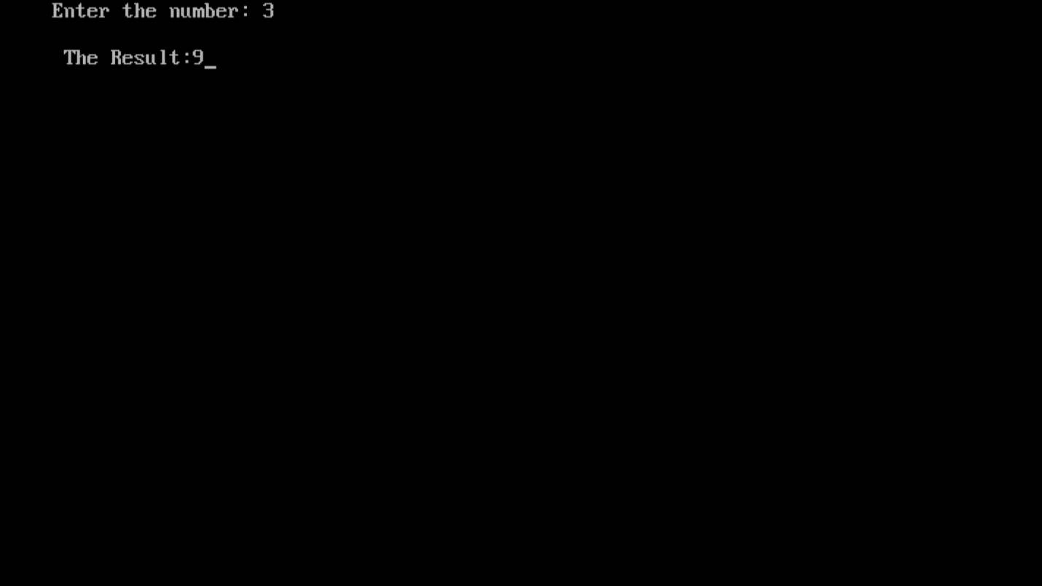

3.PROGRAM ON STRLEN():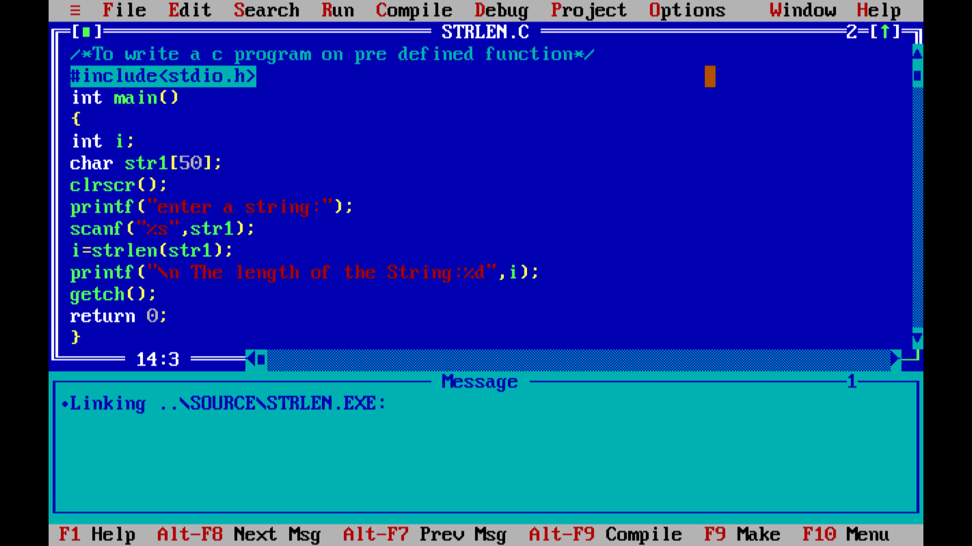

OUT PUT: for pre defined function strlen()

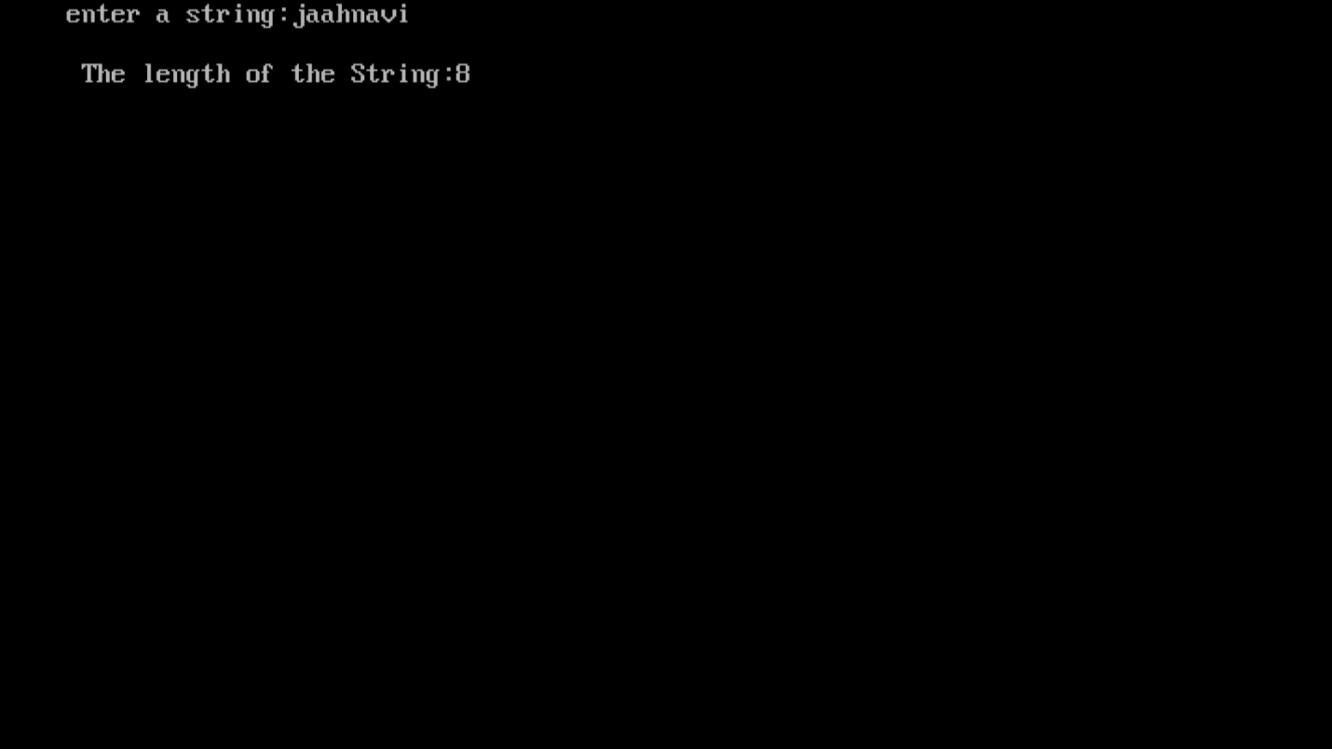

4.PROGRAM ON STRREV():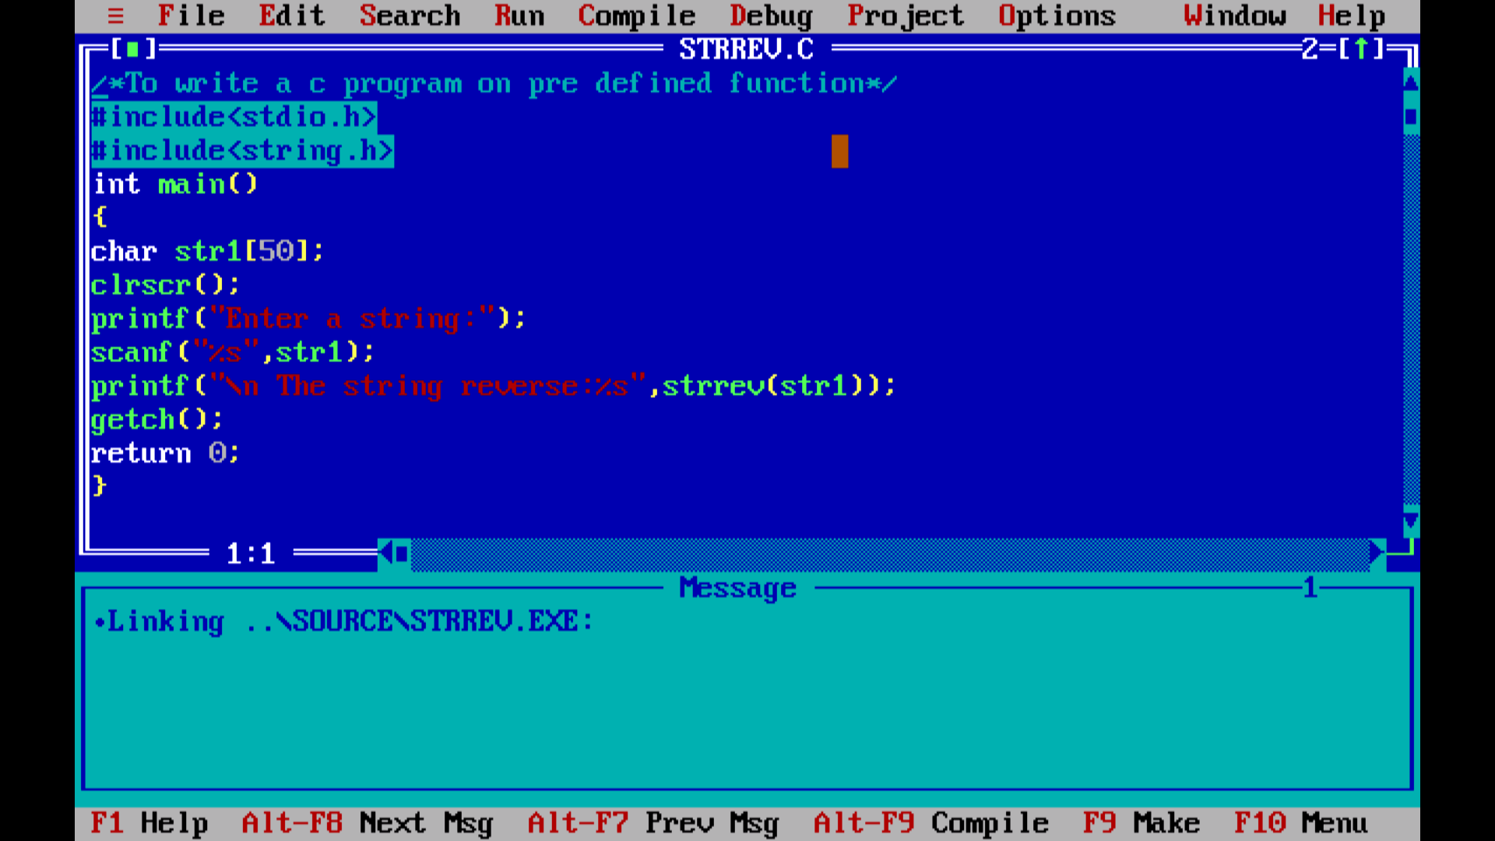

OUT PUT: for the pre defined function strrev()

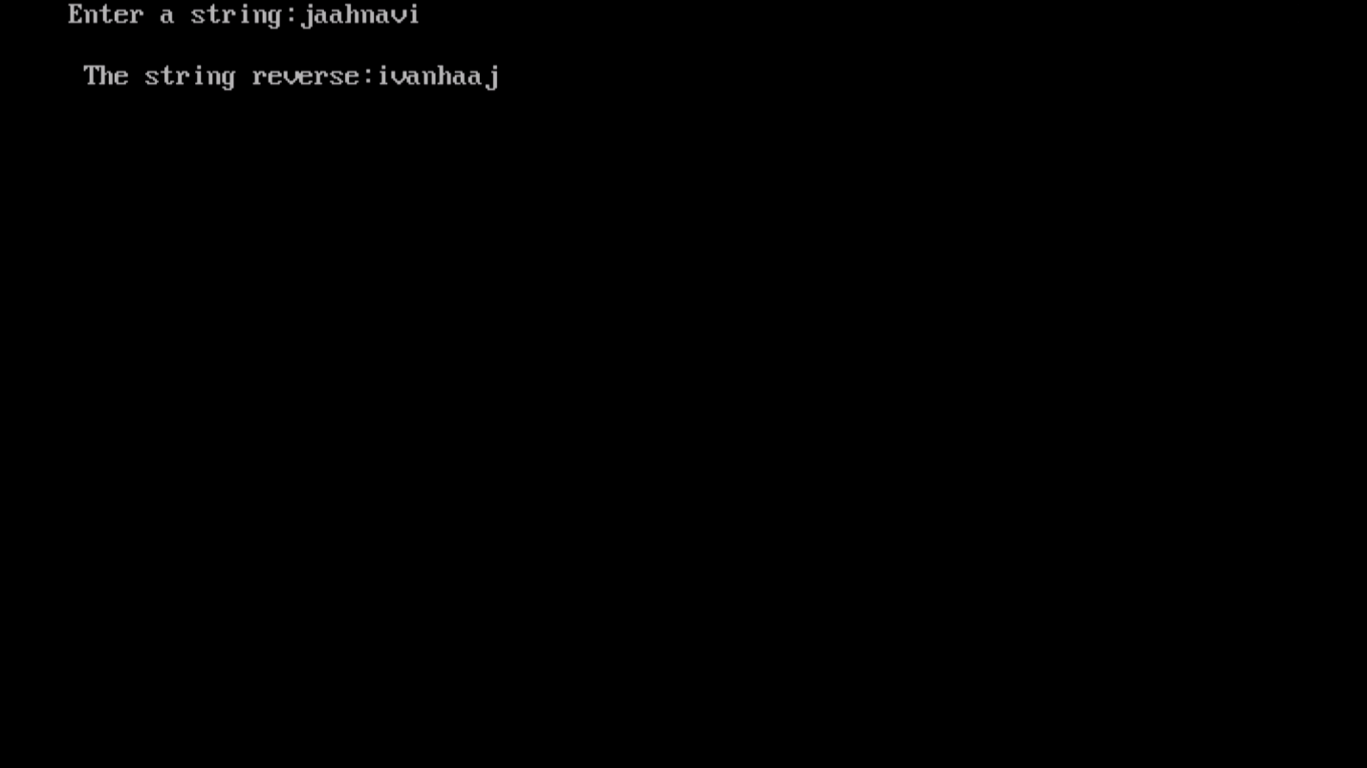

5.PROGRAM ON STRCMP():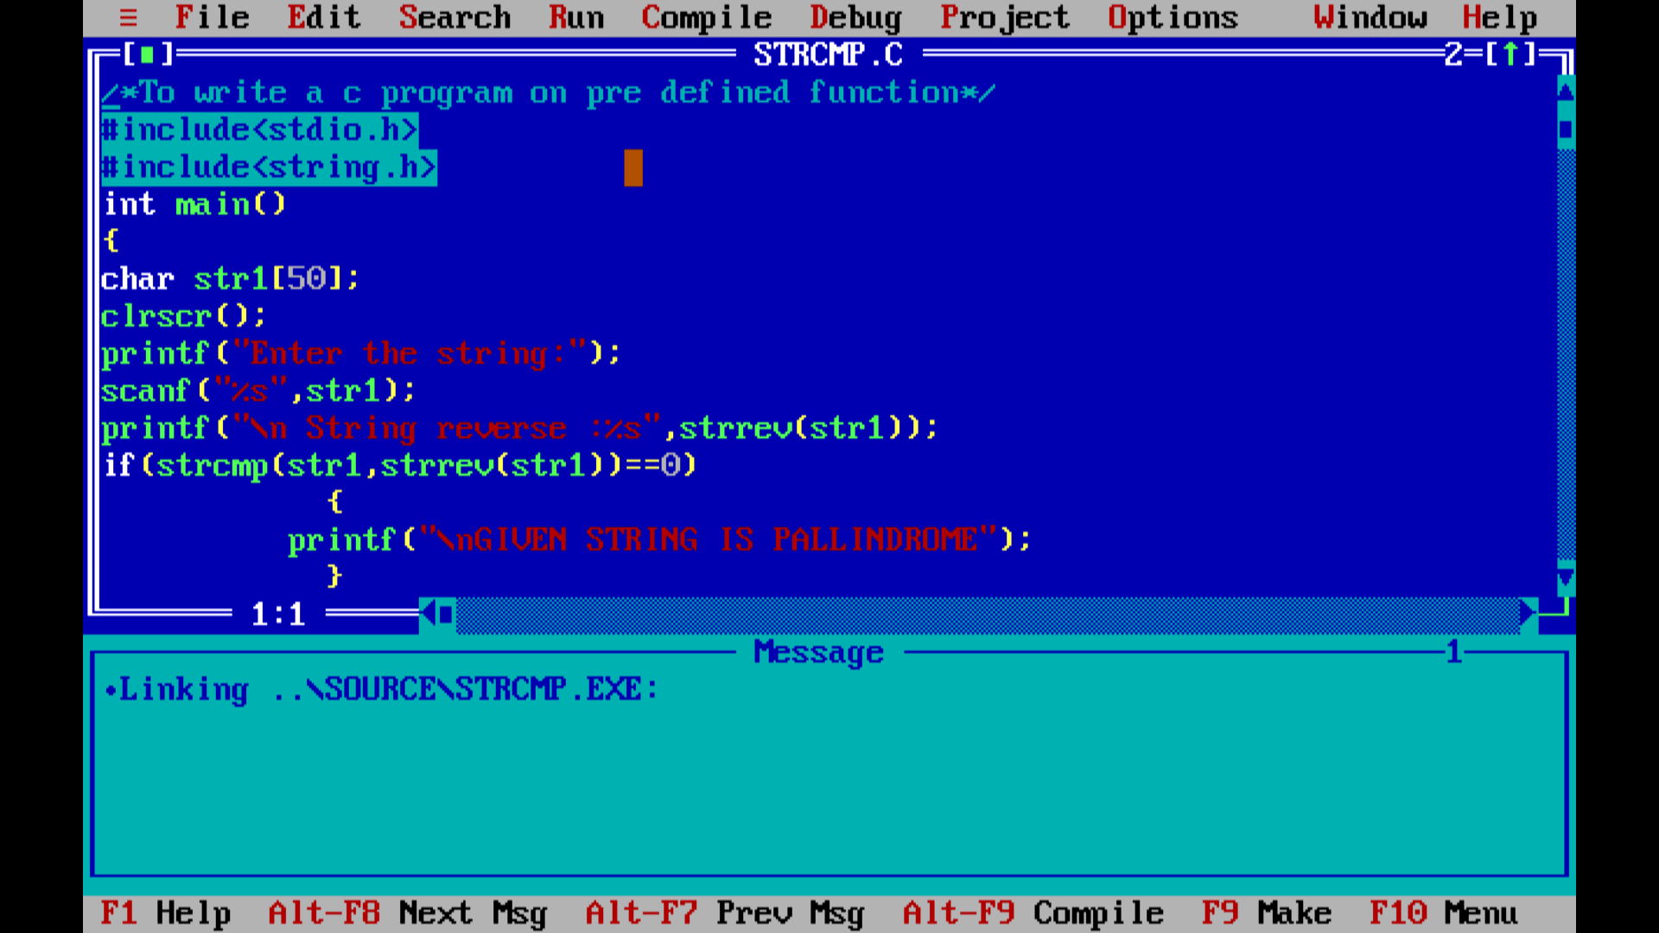

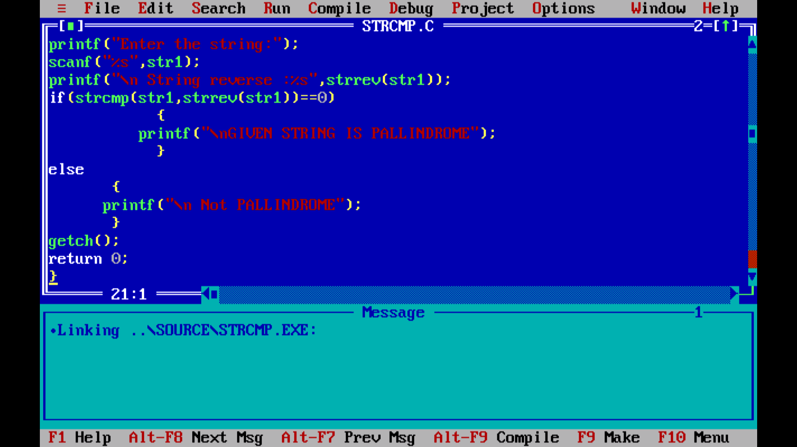

OUT PUT: for the pre defined function strcmp()

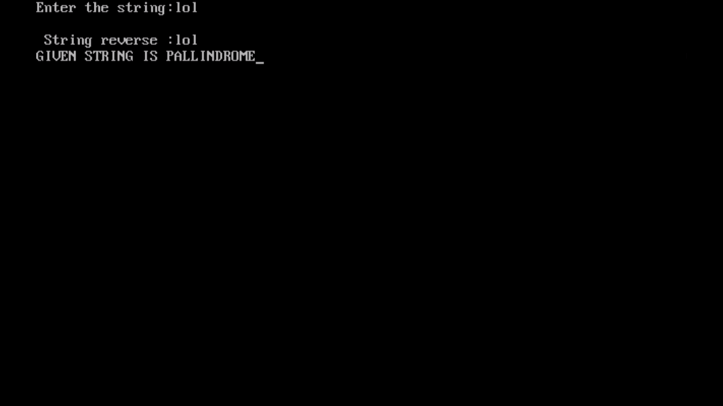

6.PROGRAM ON STRCPY():

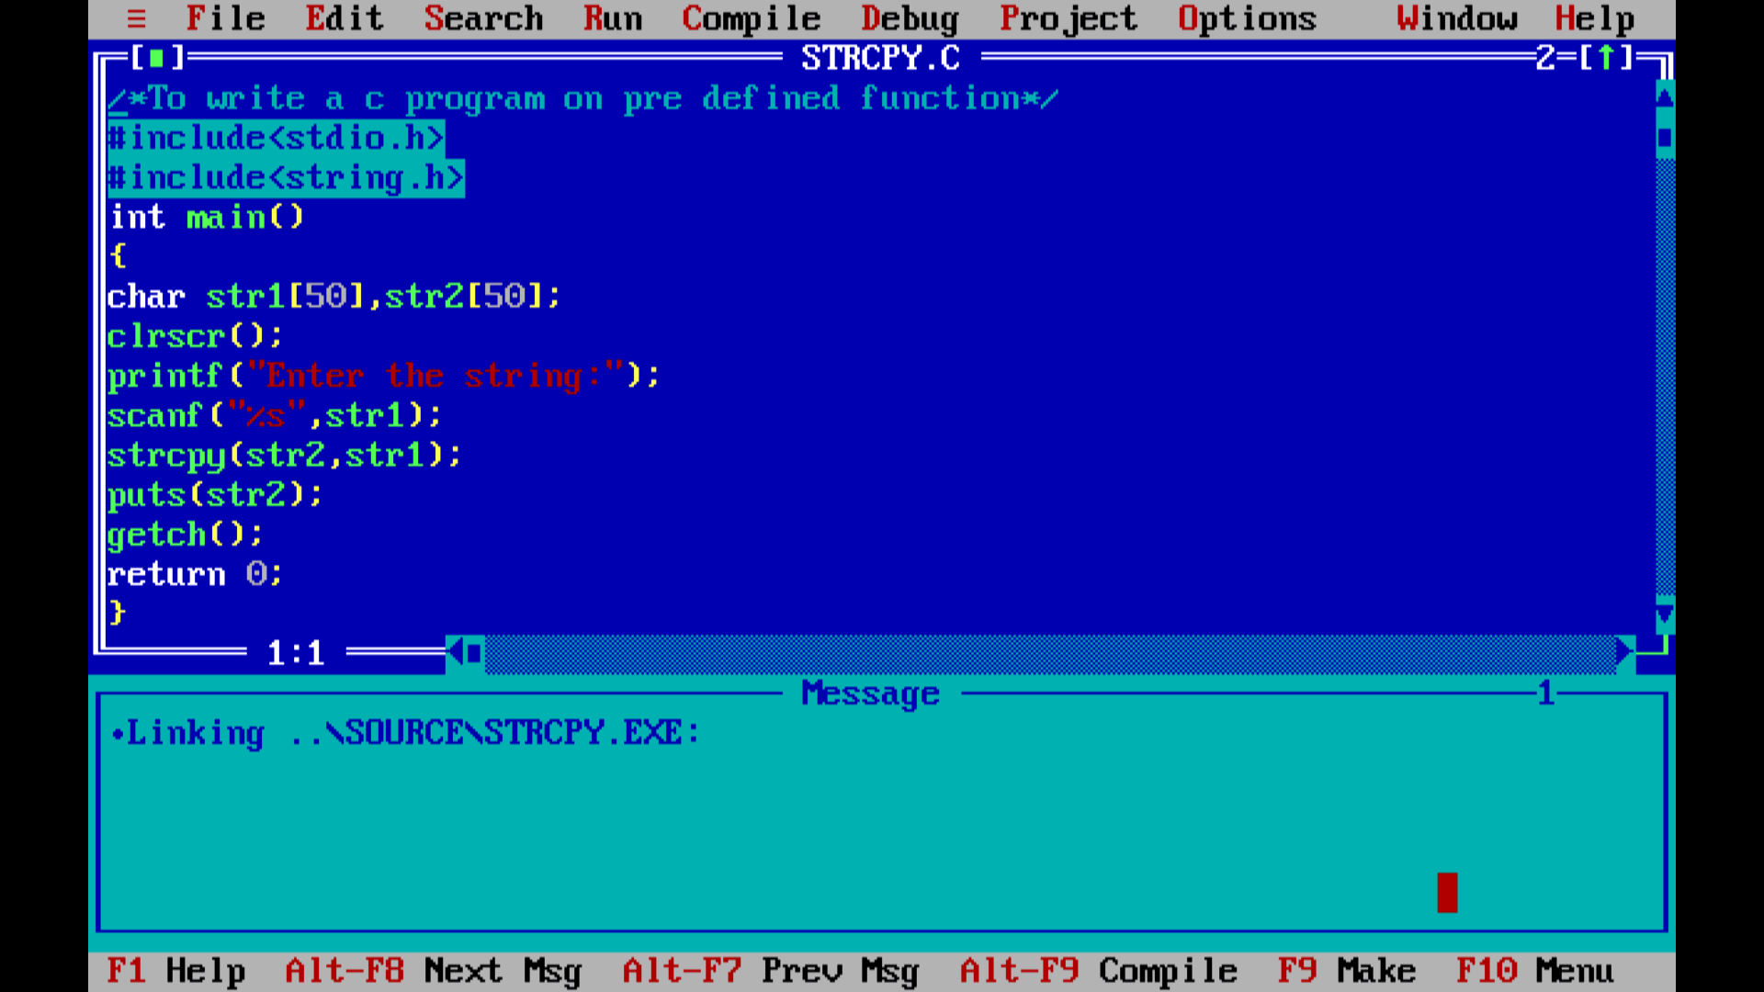

OUT PUT: for the pre defined function strcpy()

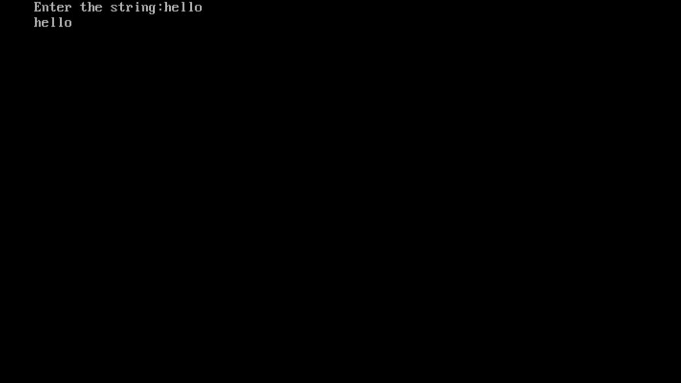

7.PROGRAM ON STRUPR():

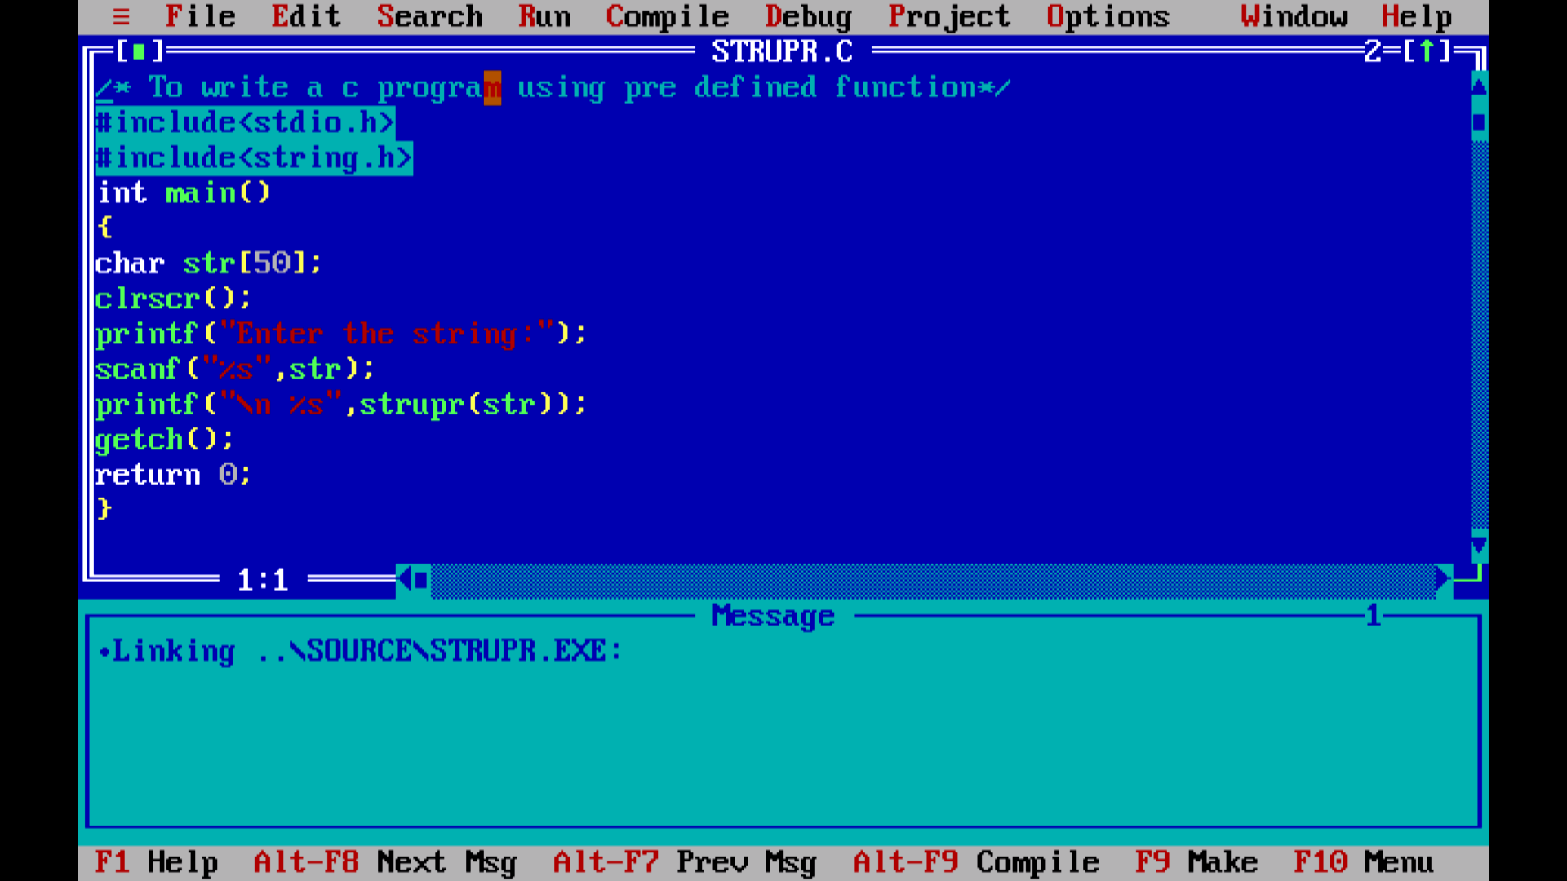

OUT PUT: for the pre defined function strupr()

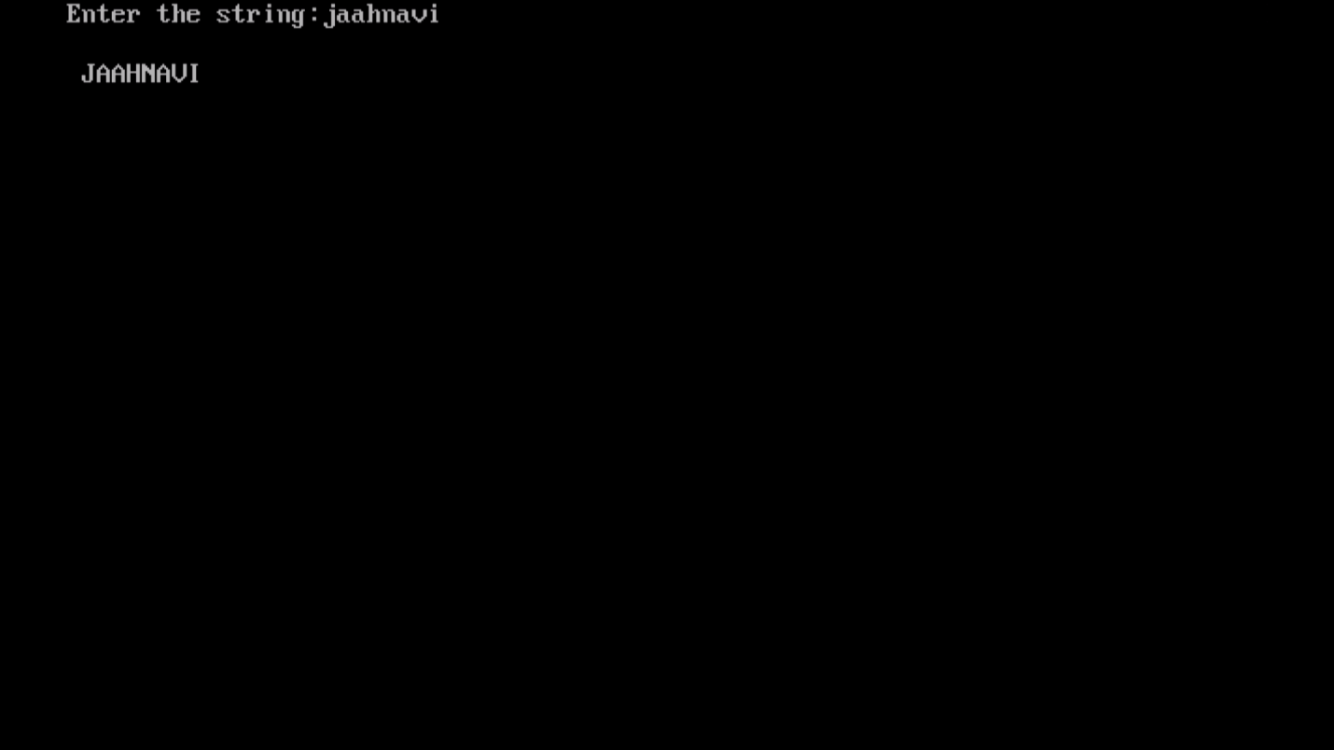

8.PROGRAM ON STRLWR():

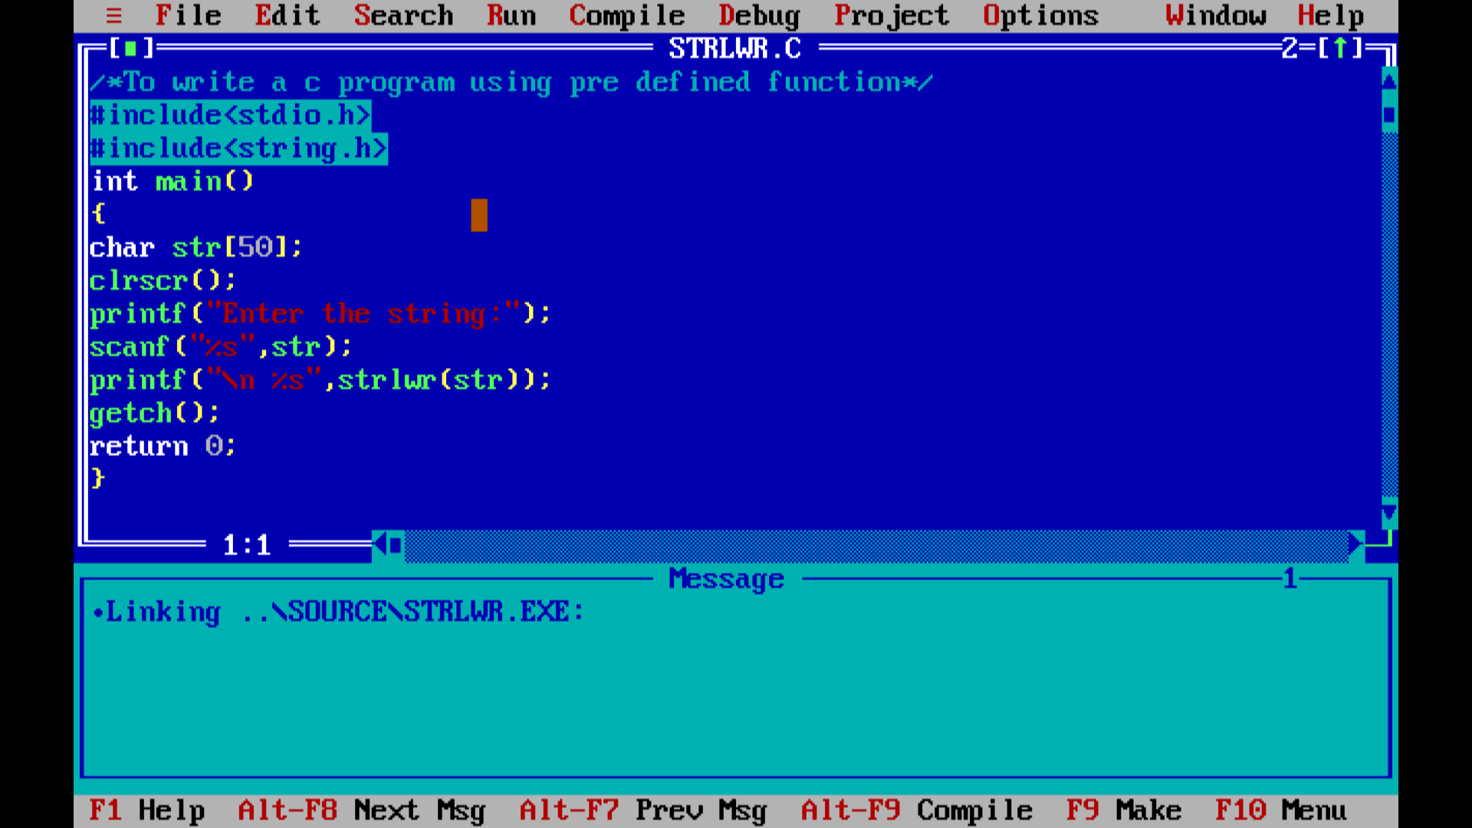

OUT PUT: for the pre defined function strlwr()



9.PROGRAM ON CEIL():

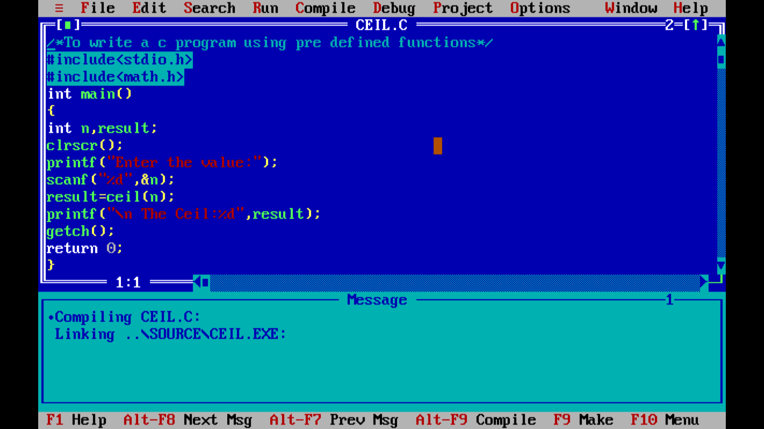

OUT PUT: for the pre defined function ceil()

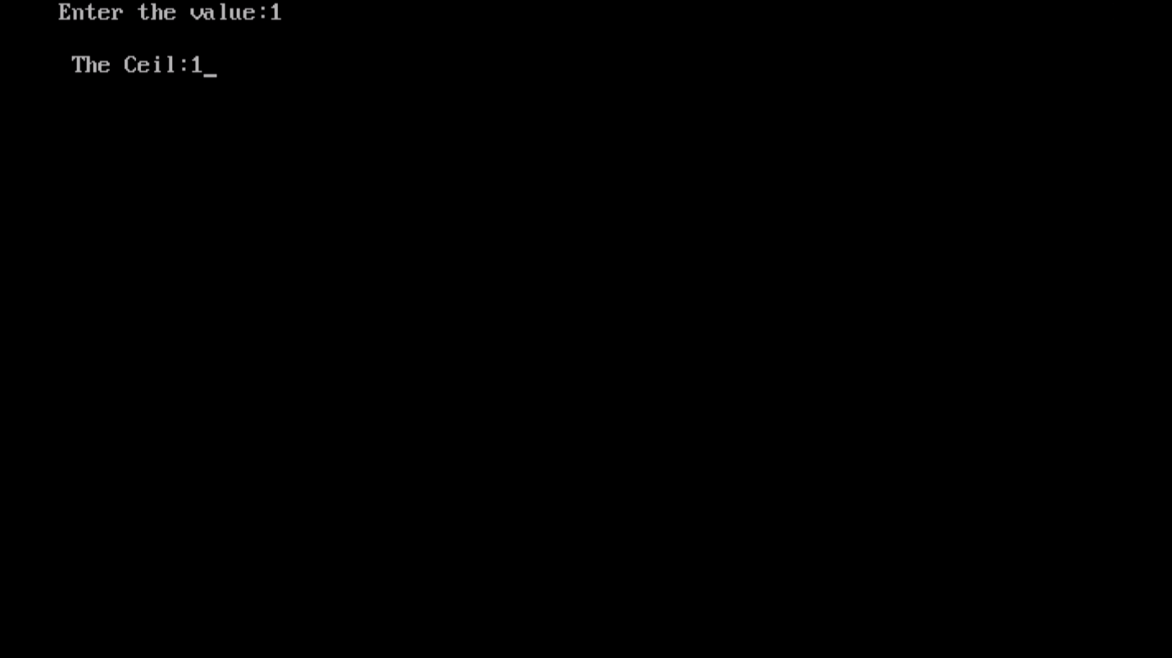

10.PROGRAM ON FLOOR():

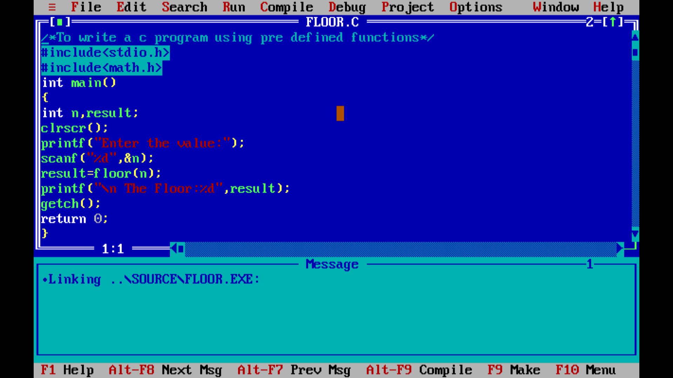

OUT PUT: for the pre defined function floor()

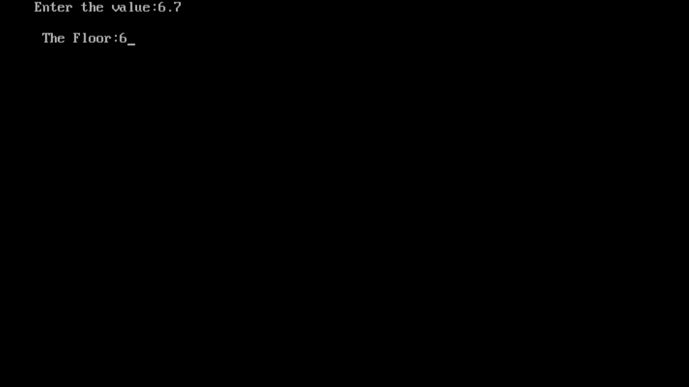

11.PROGRAM ON RAND():

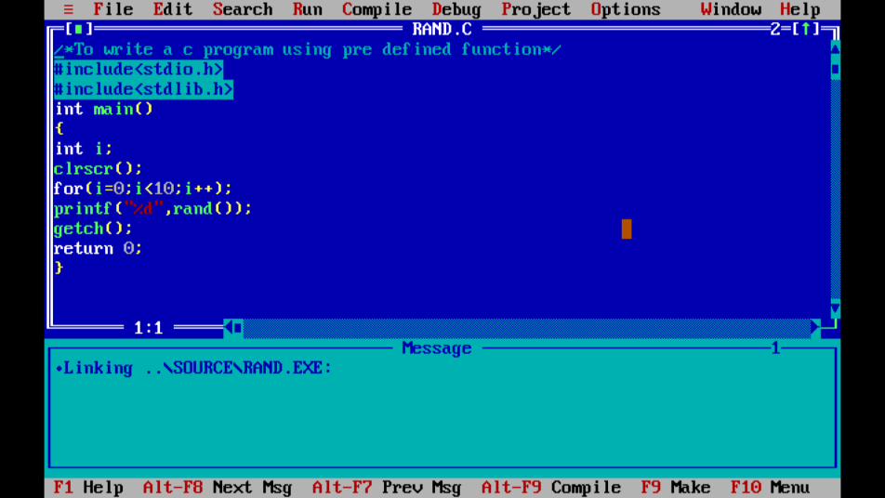

OUT PUT: for the pre defined function rand()

